SQL PROJECT ON 2ND Hand Car Dealership

1. Show all data from the table?

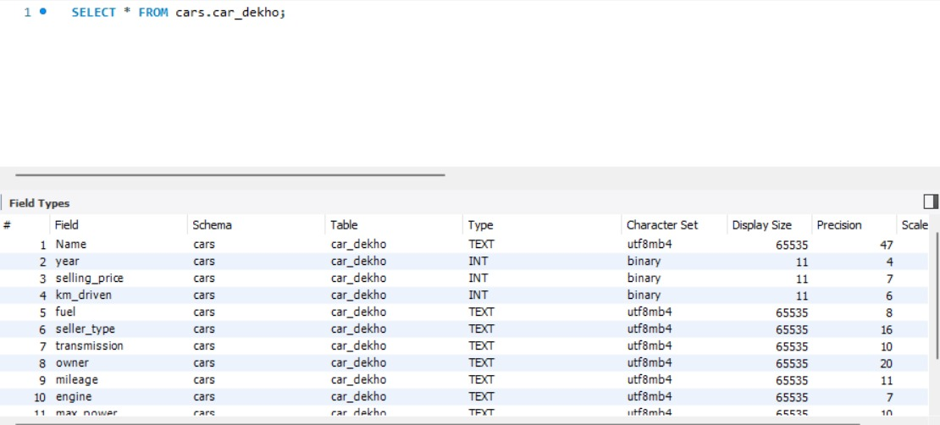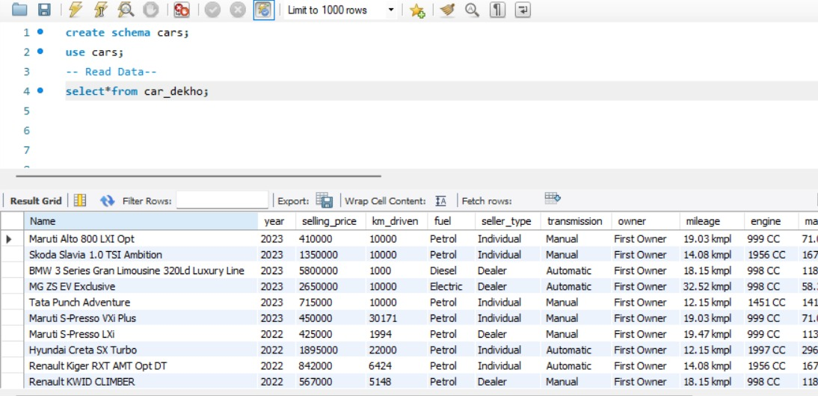

1. Show the total count of records present?

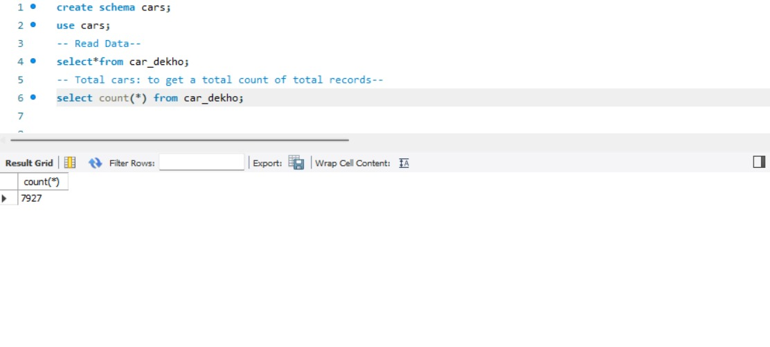

1. The manager who asked the employee how many cars will be available in 2023?

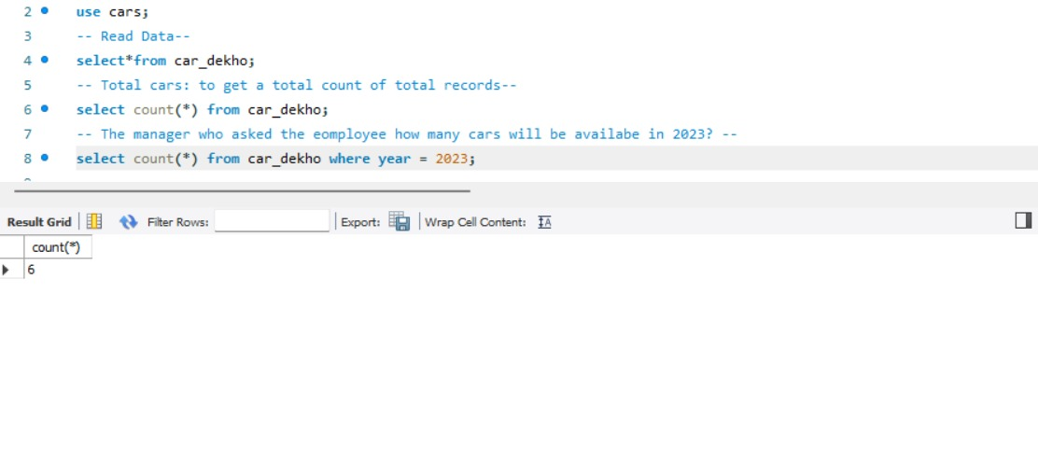

1. The manager who asked how many cars will be available in 2021, 2022, 2023?

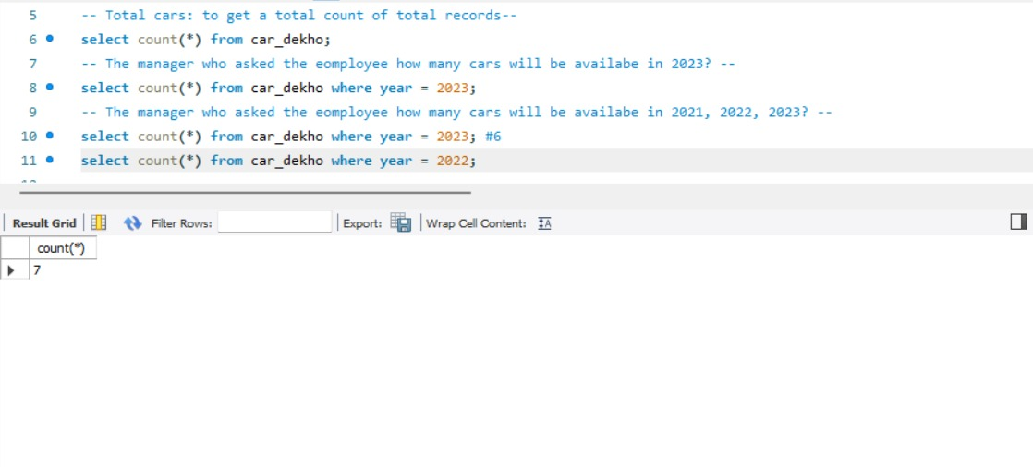

1. The manager asked how many cars will be available in 2021, 2022 and 2023 at once?

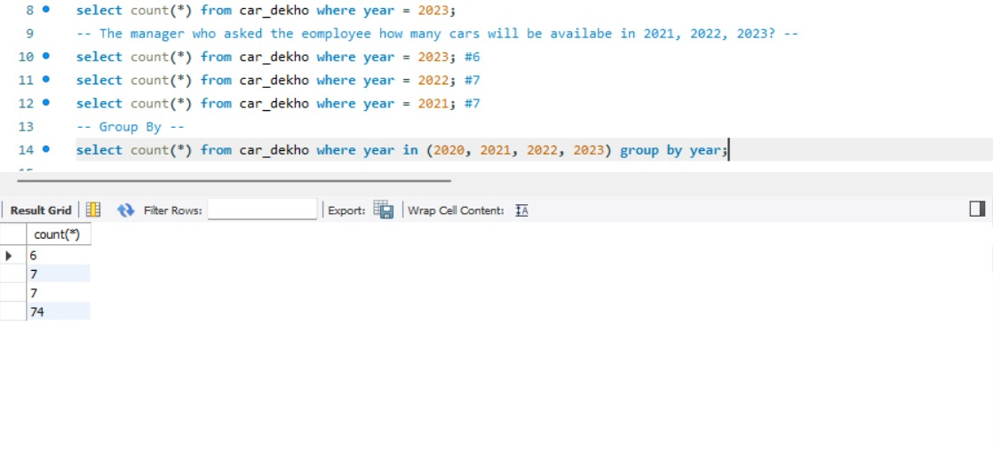

1. Client asked to print the total of all cars by year.

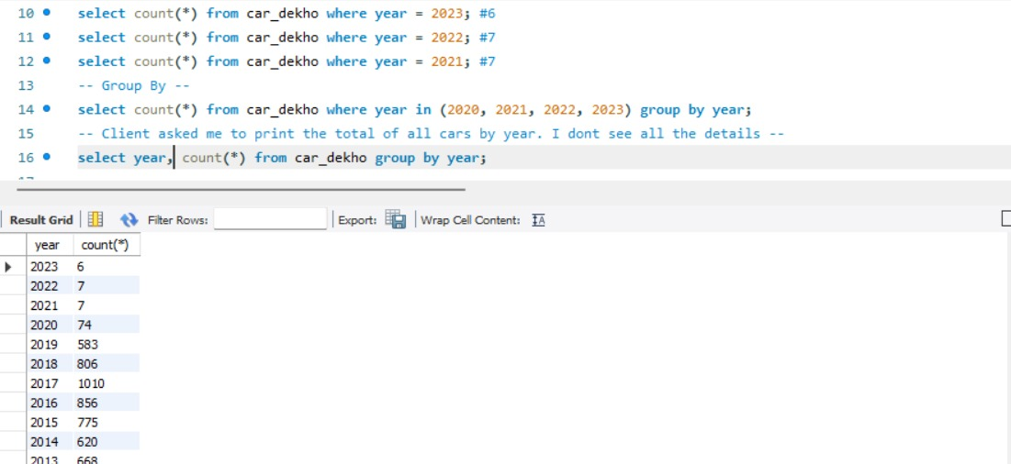

1. Client asked the car dealer agent. How many diesel cars will be there in 2020?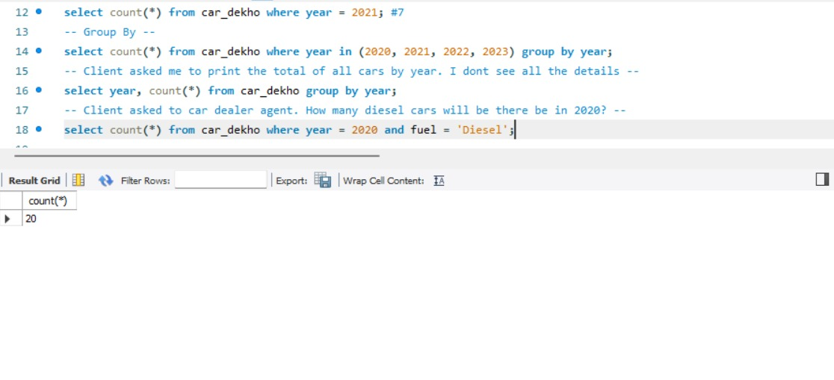
2. Client wants to know how many petrol cars will be there in year 2020?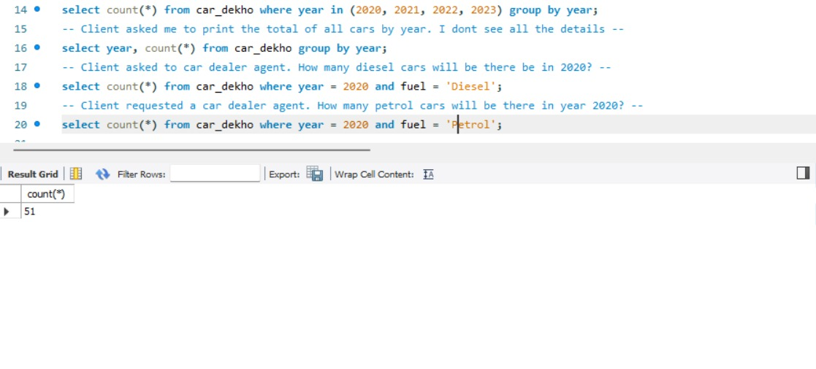
3. The manager asked the employee to give all the details of fuel cars(petrol, diesel, cng) of all year.

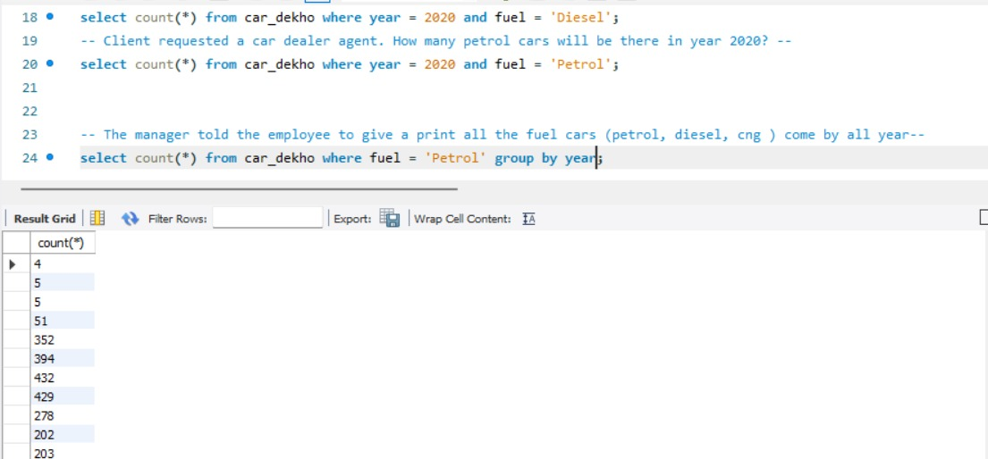

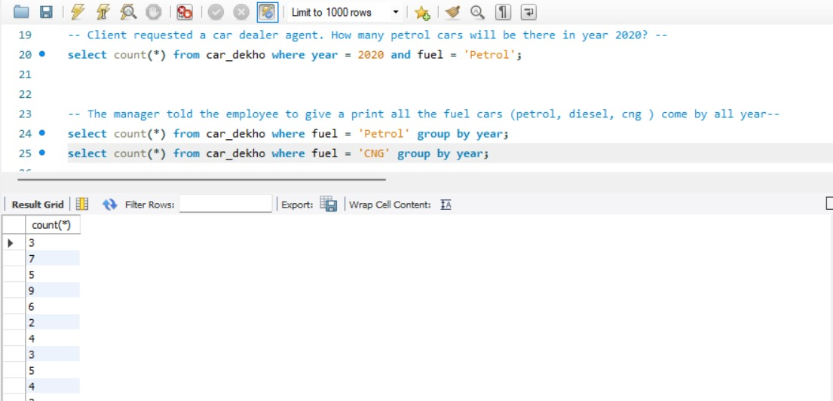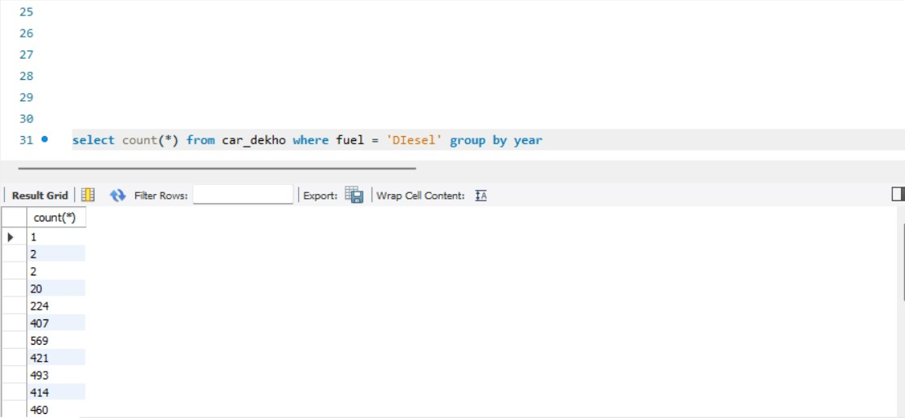  
  
10. The manager told there were more than 100 cars in a given year, please find out which year it is?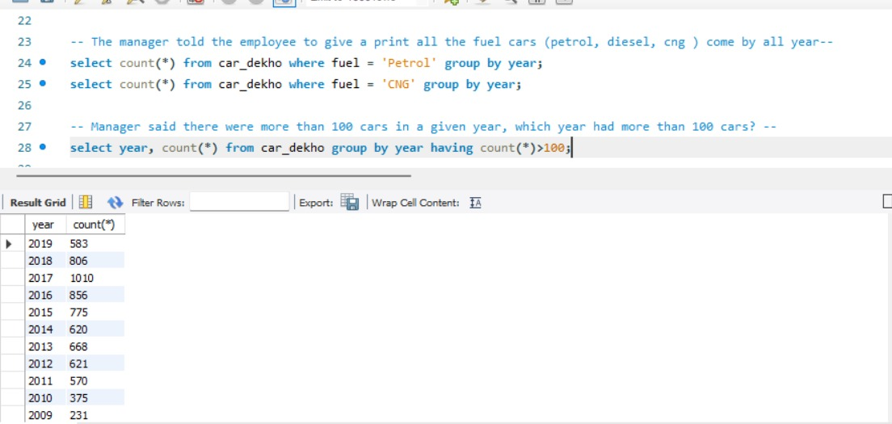  
  
  
11. The manager asked to show cars from year where total cars sold are below 50?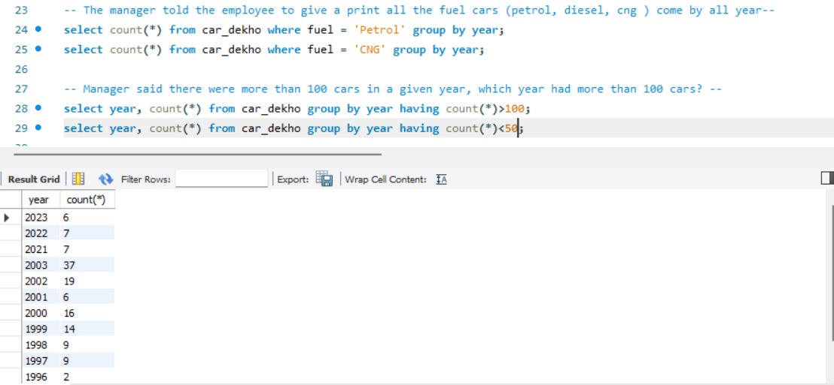  
  
12. The manager asked the total number of cars present between 2015 – 2023?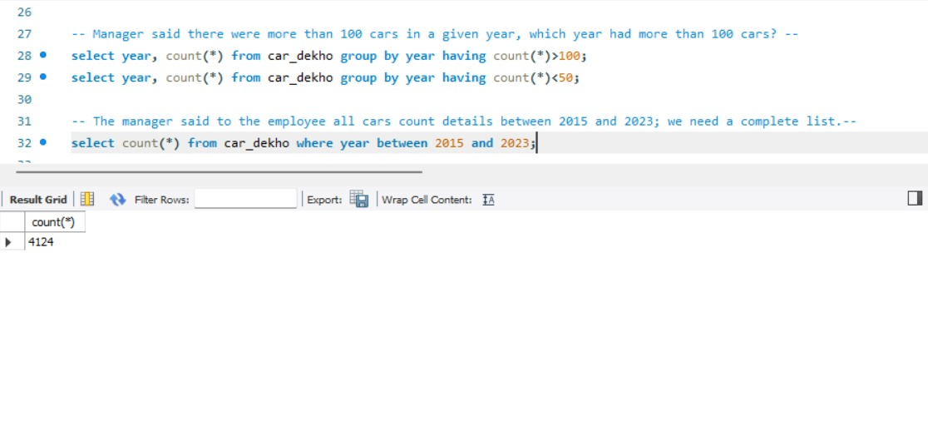  
  
  
  
  
  
  
  
  
  
  
  
  
  
  
13. The manager asked to show every details of the cars present from year 2015- 2023?